**Lab 4: Programming Symmetric & Asymmetric Crypto**

1. **Importing the necessary libraries:**

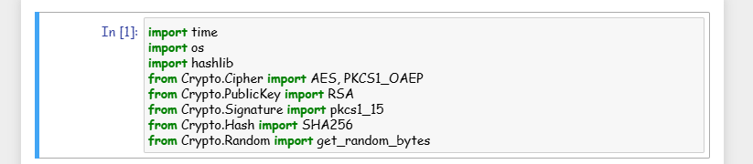

1. **AES encryption/decryption with two key lengths, 128 and 256 bits, and two modes ECB and CFB:**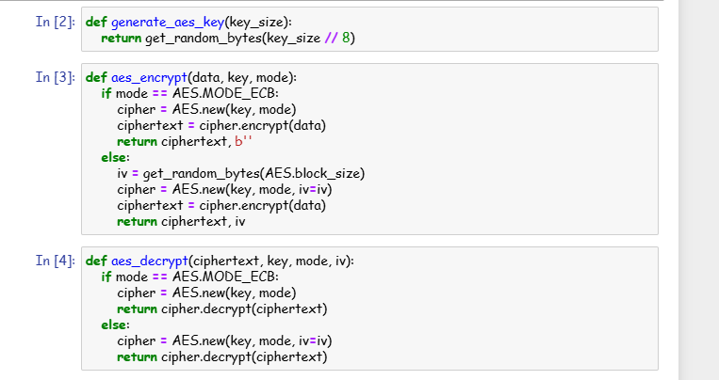

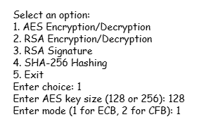

1. **RSA encryption and decryption:**

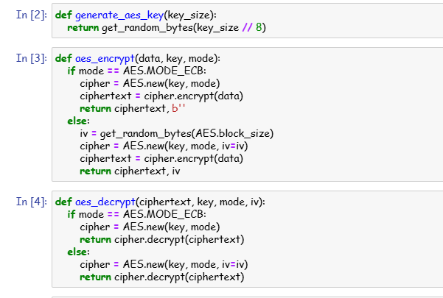

1. **RSA Signature:**

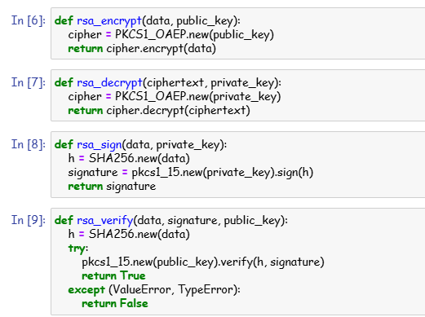

* **RSA signature:**



1. **SHA-256 hashing:**

**Lab 5: Securing Apache Web Server**

**Task-1: Becoming a certificate authority**

1. **Configure openssl.cnf:**
2. Copying the openssl.cnf file from /usr/lib/ssl/openssl.cnf to current directory.
3. Modifying openssl.cnf to suit the requirements, focusing on adjustments within the [CA_default] section to define directories and settings appropriately.

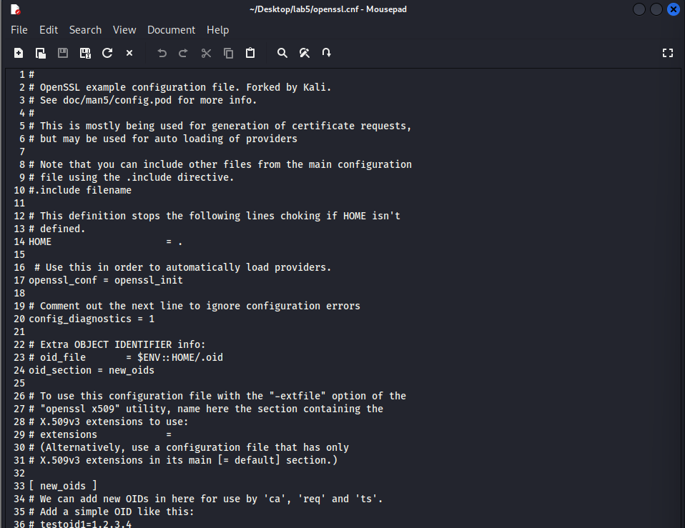

1. **Generating a self-signed certificate for our CA, filling in necessary information such as Country Name, Common Name, etc.**

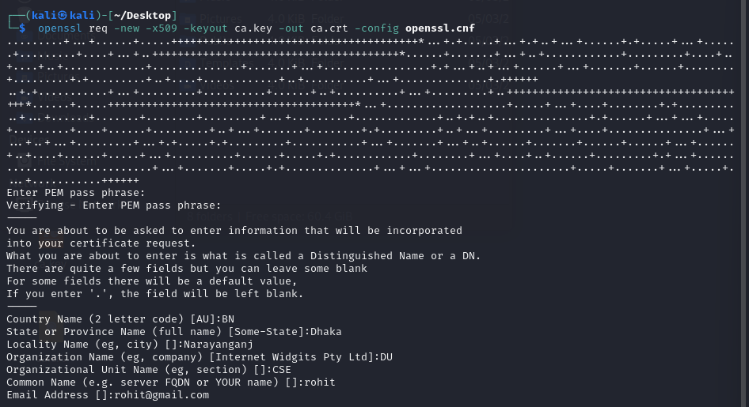

The output of the command is stored in two files: ca.key and ca.crt. The file ca.key contains the CA’s private key, while ca.crt contains the public-key certificate.

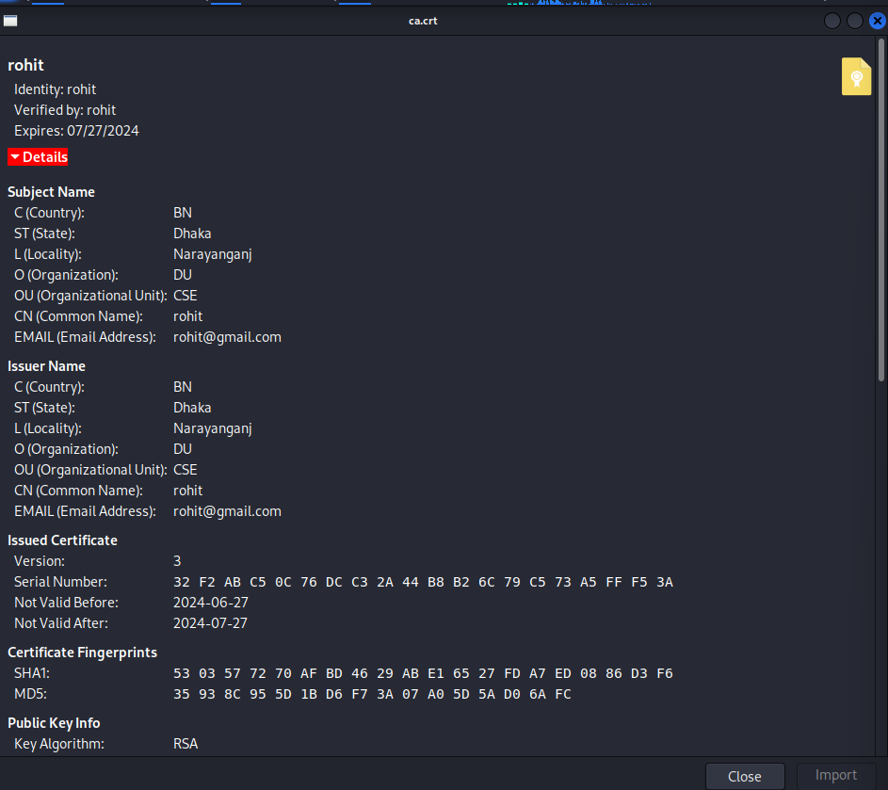

**Task-2: Creating a certificate for example.com**

1. **Generating public/private key pair.**

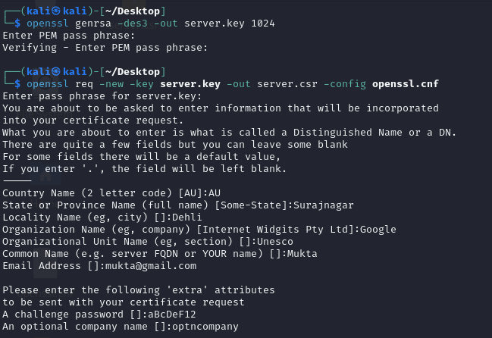

1. **Generating a Certificate Signing Request (CSR).**



1. **Generating Certificates**
2. The names in your requests do not match with those of CA. So, OpenSSL refuses to generate certificates.

1. Fix this and re-issue the above command.

**Task-3: Launching a simple web server with the certificate generated.**

1. **Combining the secret key and certificate into one file.**

1. **Launch the web server using server.pem.**



1. **error message from the browser**

1. **Manually adding our CA’s certificate to the Firefox browser. A screenshot of a computer

   Description automatically generated A screenshot of a computer

   Description automatically generated A screenshot of a computer

   Description automatically generated A screenshot of a computer

   Description automatically generated A screenshot of a computer

   Description automatically generated** 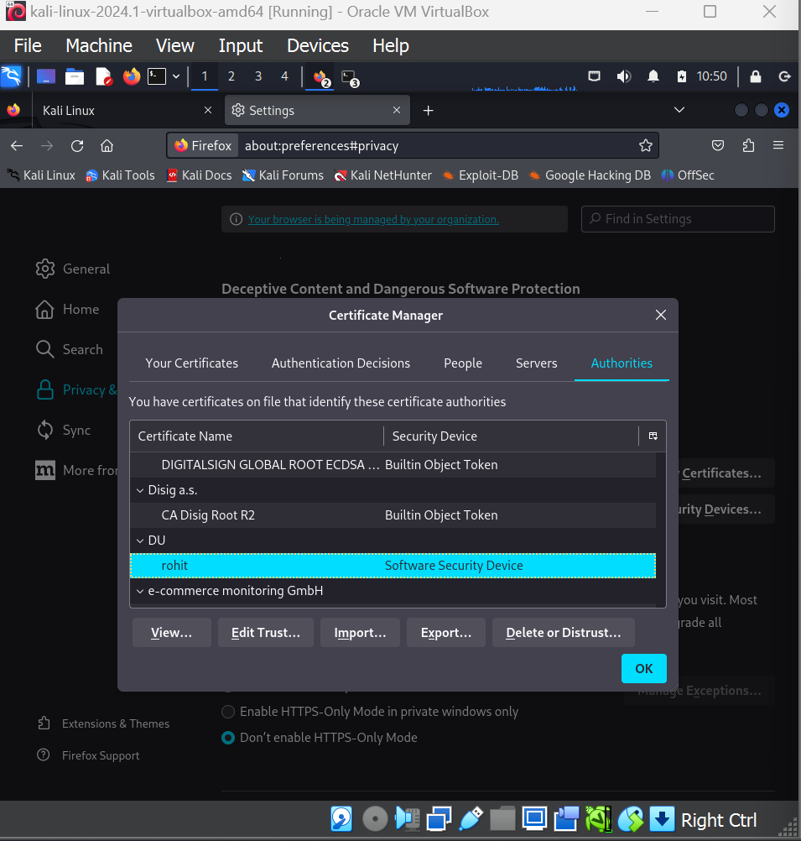
2. **In webpage, showing certificaticates’ details.**

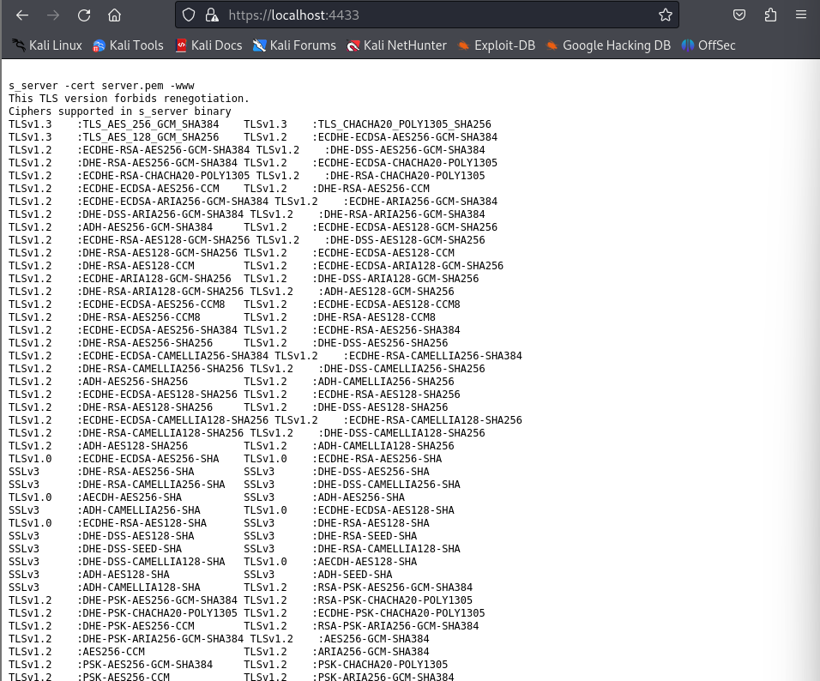

**Task-4: Deploy HTTPS into Apache**

1. **Writing contents in /etc/apache2/sites-available/example.com.conf file.**

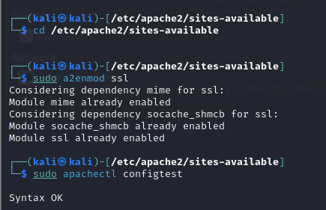

1. **Restarting the apache server.**
2. **Now, try to access the** [**http://example.com**](http://example.com)**. It’ll view the webpage in HTTPS.**

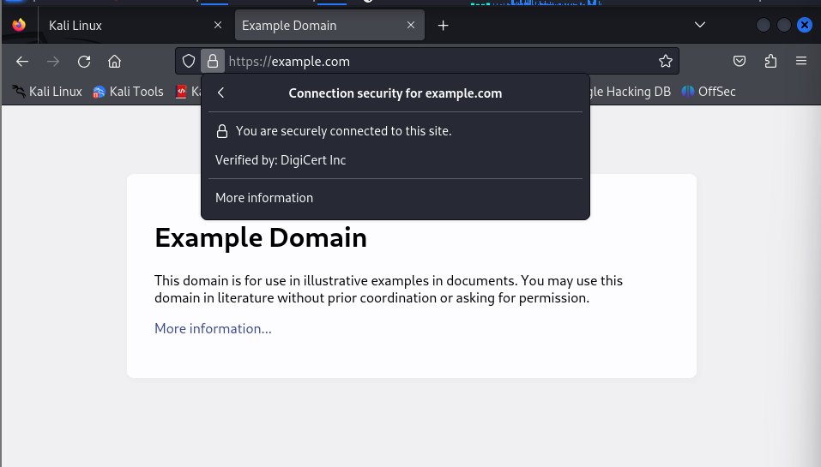

**Lab 6: Securing Apache Web Server – 2**

**Task – 1:**

1. **Enable the mod_rewrite module using a2enmod command.**

1. **Look at the /etc/apache2/sites-enabled directory to find the configuration file for port 80 for example.com**

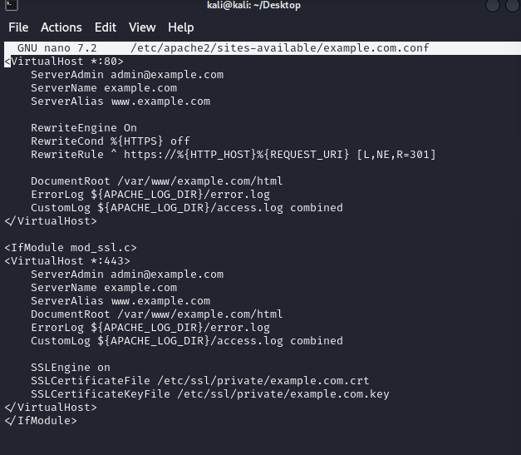

1. **Testing Apache configuration and restart the Apache server.**

1. **Testing example.com on your browser. It’ll show “Hello, World!”**

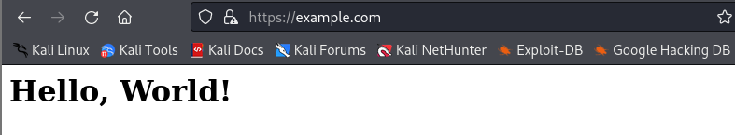

**Task-2:**

1. **Adding users to Apache web server using the following command:**

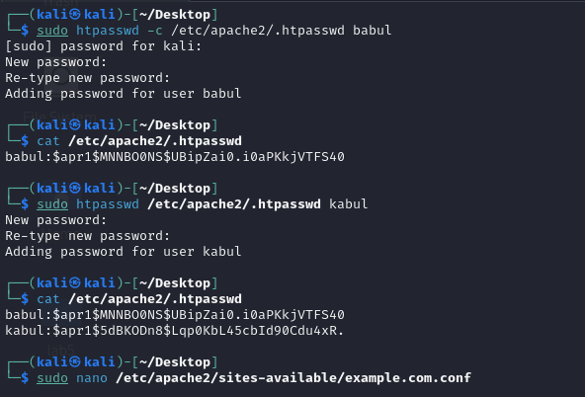

1. **Use the following command to cat the contents of .htpasswd file.**



1. **Adding a few lines into https configuration file for example.com.**



1. **Restarting the apache server.**
2. **When accessing to example.com, it’ll show a prompt to give username and password.**

1. **Now providing the username and password from before created.**

1. **Now, I can access the site.**

**Task-3:**

1. **Installing and configuring Mariadb server on kali linux.**

1. **Creating a database called ‘apache’ and use the following command to use the apache database.**

1. **Creating a table called users**

1. **Instead of storing plain passwords in database, use the following command to create a hashed password for users named Sammy and Alice in a separate consoleA screenshot of a computer program

   Description automatically generated**
2. **Now store the hashed password**

1. **Enable the mod_authn_dbd module of Apache and modifying configuration file’s contents.**

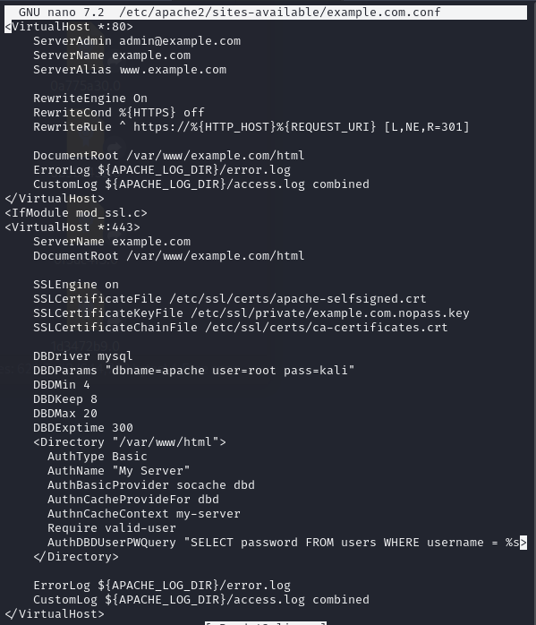

1. **Restart the Apache server.**
2. **When accessing the example.com page, it’ll show a prompt for username/password. Providing the one that have in your MySQL database. Now you can access the page.**

